Introduction
We present a new interaction technique called the “Flip-Switch.” The motivation behind this design was to develop an interaction technique that acquires targets on a user-interface without requiring the user to click. Additionally, the goal of this technique was to overcome the occlusion problem that many mouse-based goal crossing interaction techniques face. A prototype was developed and a small user study was performed.
Flip-Switch Method
The flip switch method involves a line, that when crossed, pivots on one of its ends as though it is being pushed by the pointer. When the goal is crossed, a 2nd goal appears 180 degrees from the initial goal. The user is now in the activation mode and all other goals are deactivated. To finish activating the goal, the user must travel the 180 degrees and cross the 2nd goal. A circular arc boundary exists between the two endpoints of the goals. If the user exits the boundary before crossing the 2nd goal, then the 2nd goal disappears and the goal is not activated.
Subjects
5 subjects were recruited for this study. There were 2 males and 3 females with an average age of 23.8. All of them were right handed and were proficient mouse users.
Apparatus
The method was developed in JavaScript. The prototype was run on Opera 9.5 browser with a Microsoft 3 button intellimouse pointing device on an iMac running Microsoft Vista.
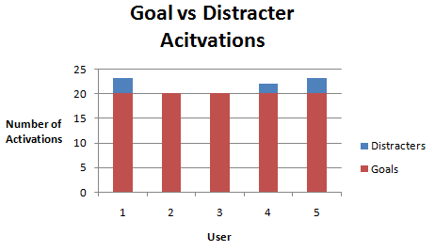Procedure
Each user was told that they did not have to click to acquire the targets, but they were not told how to acquire the targets or how the interaction technique worked. They were also told that they had to start with their mouse from the arrow picture and then the goal they were suppose to acquire would be highlighted red. After the user successfully activated a target, a new cardinal direction was chosen for the user. Each of the 5 targets had to be activated 4 times, once from each of the 4 cardinal directions: north, south, east and west. The order of the targets was chosen at random at the beginning of each experiment.
Results
Error Rate: In our experiment, we took an error to be an activation of a distracter goal. There was a total average of 8% error rate across all users, with 2 of those users having an error rate of 0%.
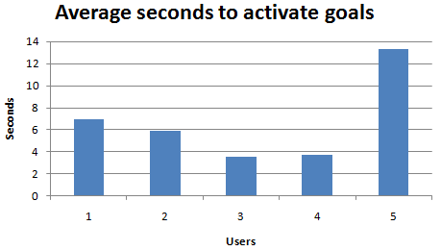Performance: Due to the nature of our experiment we were unable to calculate throughput with Fitt’s Law, though we were able to calculate the average time for each user to activate their goals.
With a standard deviation of 3.98, we found that five participants were not enough to come to any conclusive performance measures for this input method.
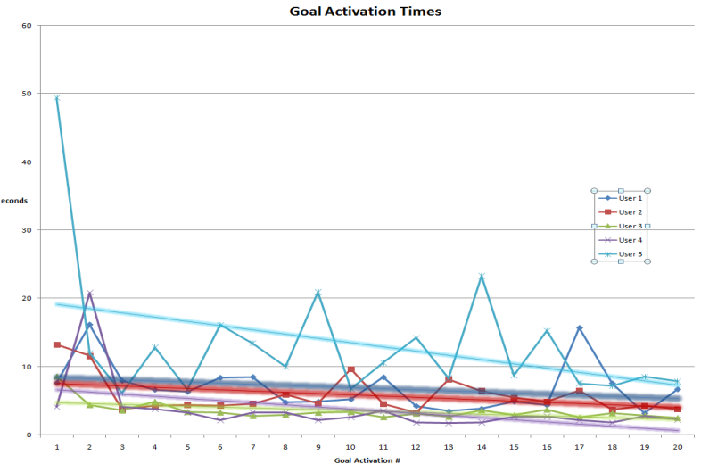Learning Curve: All of the users experienced trial times that consistently decreased over time. Qualitatively, we did observe that there may be promise for the method as some of the users enjoyed the activity and got better with time.
Conclusion
We presented an interaction technique that we call the Flip-Switch. This method utilized goal crossing in an attempt to overcome the design changes presented by zero button mice. We tested the method by building a prototype and testing it on 5 subjects. The results showed an acceptable error rate but more research must be done to evaluate the method’s performance.

